Spring BOOT

-Quckily Spring BOOT Application

- Develop a REST API using SPRING BOOT

-create SPRING MVC app with SPRING BOOT

-Connect SPRING BOOT apps to a DB for CRUD development

-no XML and only MAVEN

Introduction

Problem Study

-Building application is really HARD

que1: what Maven Archetype to use?

que2: which maven dependenies do I need?

Que3: how do I setup configuration (xml or java)

Que4 how do I install server(tomcat or jboss)

Solution

SPRING BOOT

-makes easier to start with spring deveolpment

-minimize the amount of mannual configuration

-perform auto-configuration based on props files and jar classpath

- help to resolve dependency conflicts (Maven or Gradle)

-provided as embedded HTTP server so can start quickly TOMCAT,jeety,undertow are included / embeded in applciation

Spring Initializer

-Spring Boot provide Spring initializer

-quickly to create Spring Project

- <http://start.spring.io>

-select dependencies then create Maven / Gradle project

-Import project to IDE

Spring BOOT Embedded Server

-provided an Embedded HTTP server so can start quickly

-tomcat,jetty,undertow

-no need to install server separately

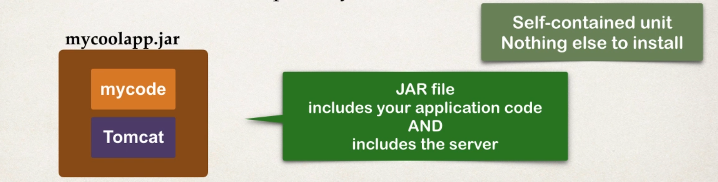

Running Spring Boot Apps

-Spring Boot apps can be run stand alone (include embedded server)

-Run the spring boot app from IDE or command line

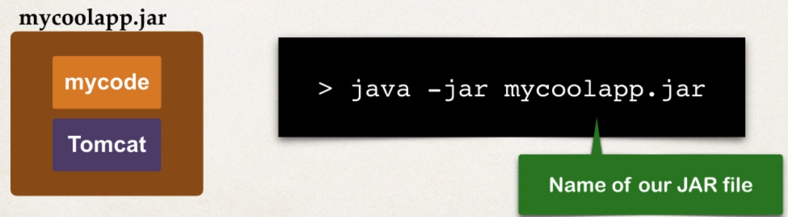

Deploying Spring Boot Apps

-Spring boot can deployed in traditionl way

- deploy a WAR file an external servers TOMCAT,JBOSS etc

- in this case only applcaition code will deployed as war file no need to include embedded server since depolying in Server only

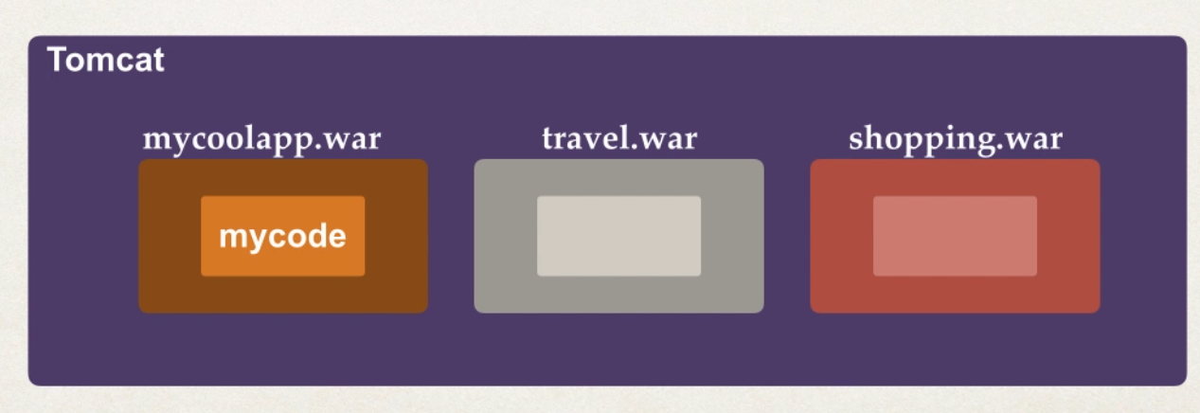

Spring BOOT FAQ

#1

Que : does Spring Boot Replace Spring MVC and Spring REST ?

- no Spring Boot actully use those technologies

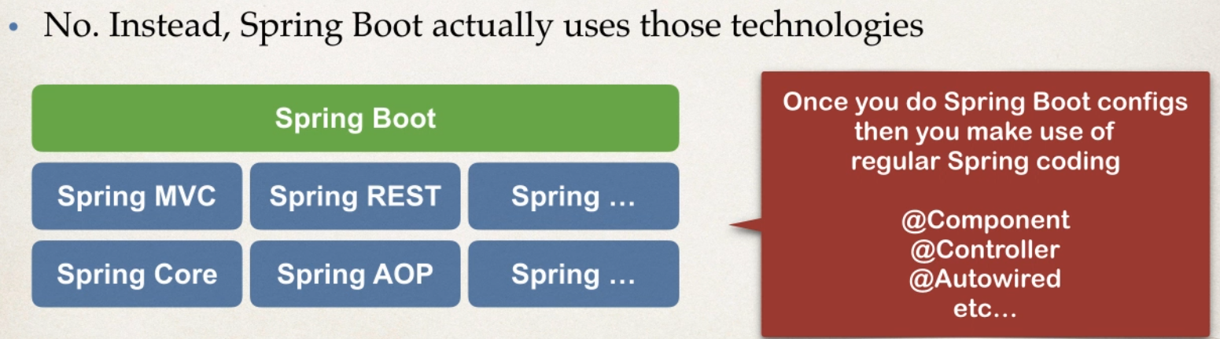

#2 Does Spring Boot code run faster then regualr Spring code

- no behind spring boot use same code code of SpringFramework it just only minimal the configurtaion and reduce hard codes, and makes easier

#3 any spl IDE for BOOT

-no we can use any IDE for BOOT even can use plain text editor

Spring Boot Initializr Demo

- go to website select dependency and project n import to IDE

<https://start.spring.io/>

Develeopment Process

1 config project at Spring Intitalizer website chose latest version avoid avoid snapshots since they are alpha /beta

Select maven,java,boot version

2 download and Import Maven Project into IDE

After import There will be class

@SpringBootApplication

public class SpringBootBaseDemoApplication {

public static void main(String[] args) {

SpringApplication.run(SpringBootBaseDemoApplication.class, args);

}

}

Run it when u run it run as java application not as Server

- bcz spring boot includes is own server no need to run on server

Run it check in browser localhost:8080

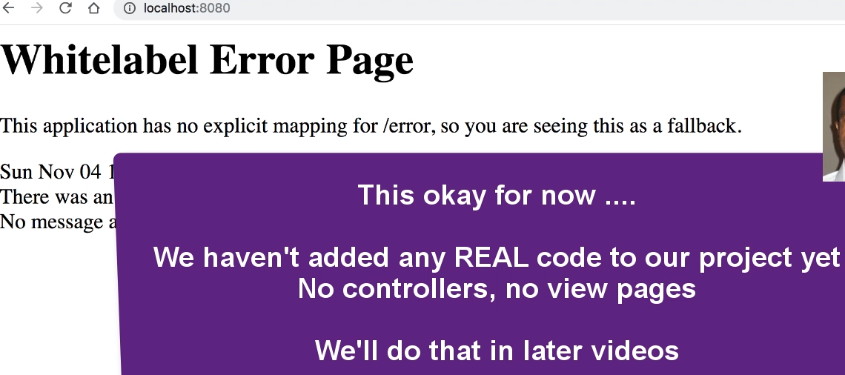

REST Controller For SPRING BOOT

-To Test Spring BOOT create RESTCONTROLLER

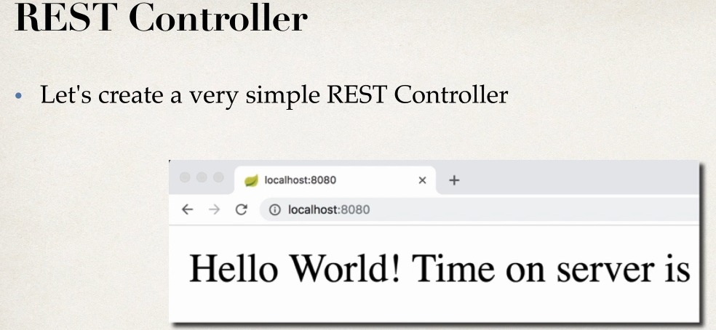

-creating Spring Rest Controller

-easy use normal spring code

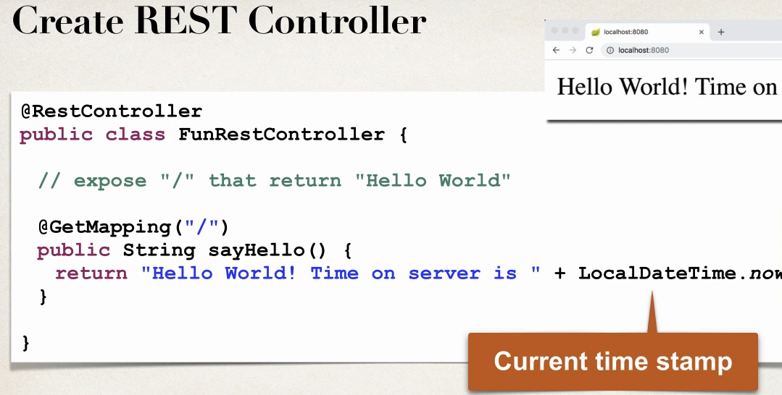

- minmisize the amount of mannual configuration

- no xml no java config non tat work will write REST controller

- no maven depencny addeed simply import project and RUN

Exploring SPRING BOOT PROJECT STRUCTURE

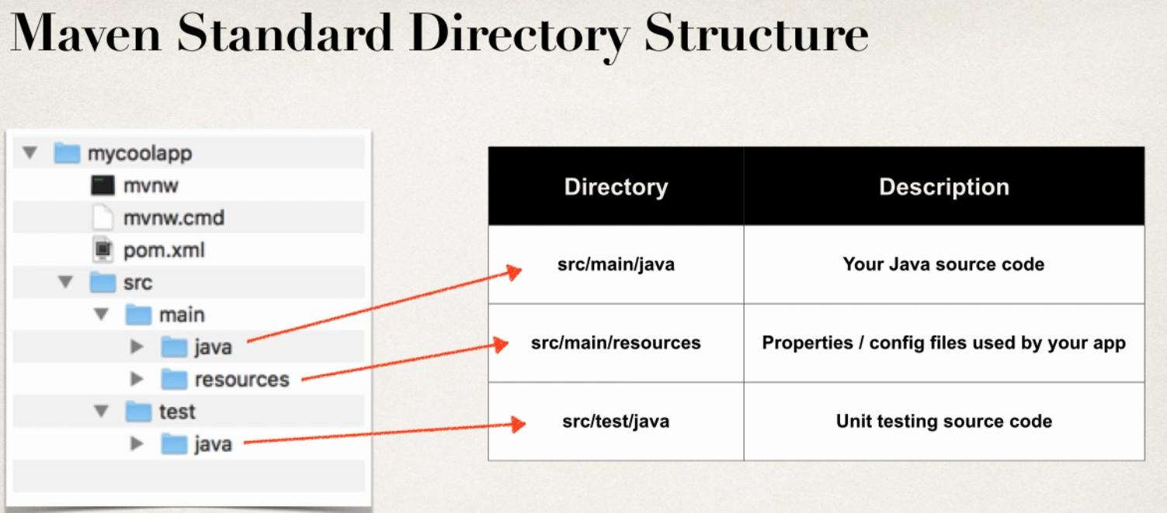

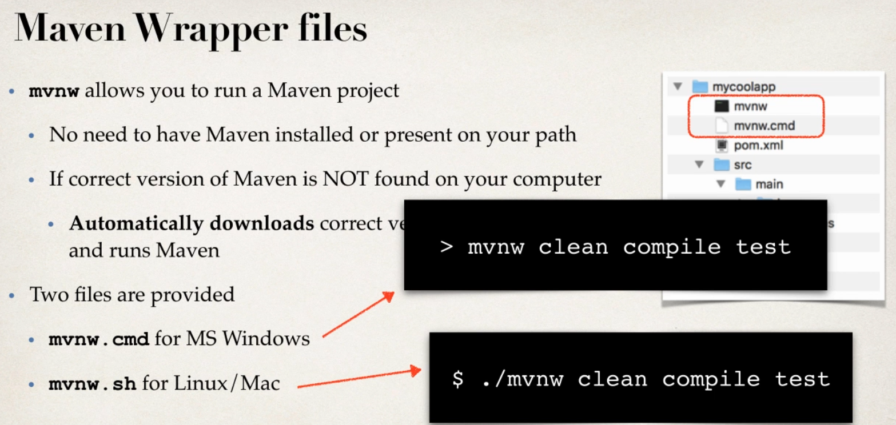

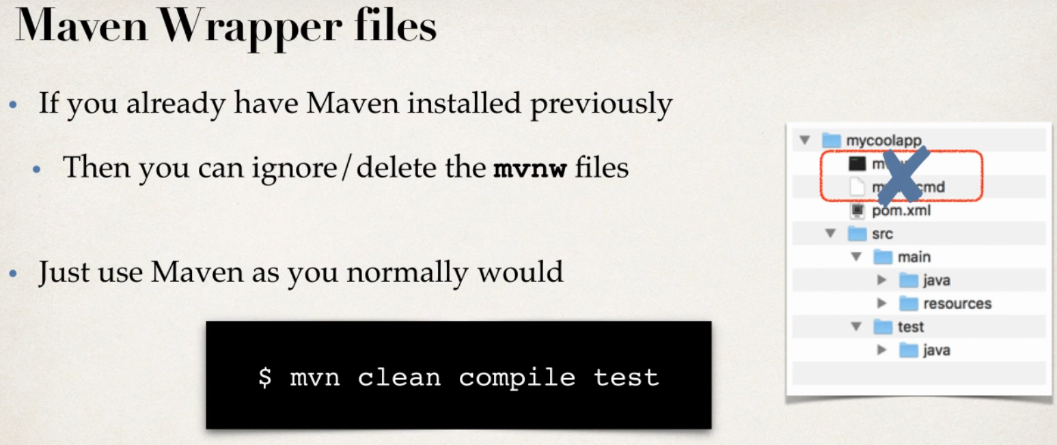

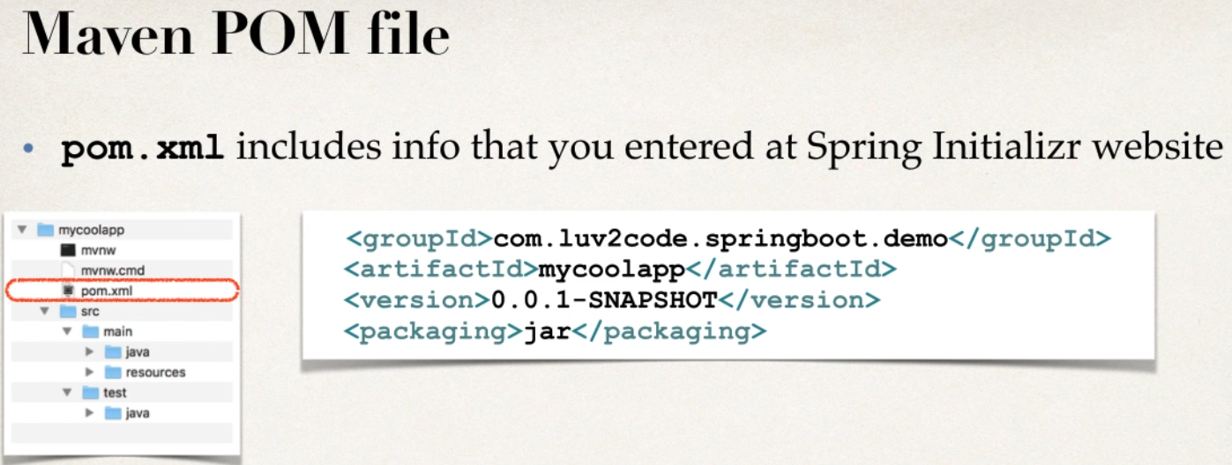

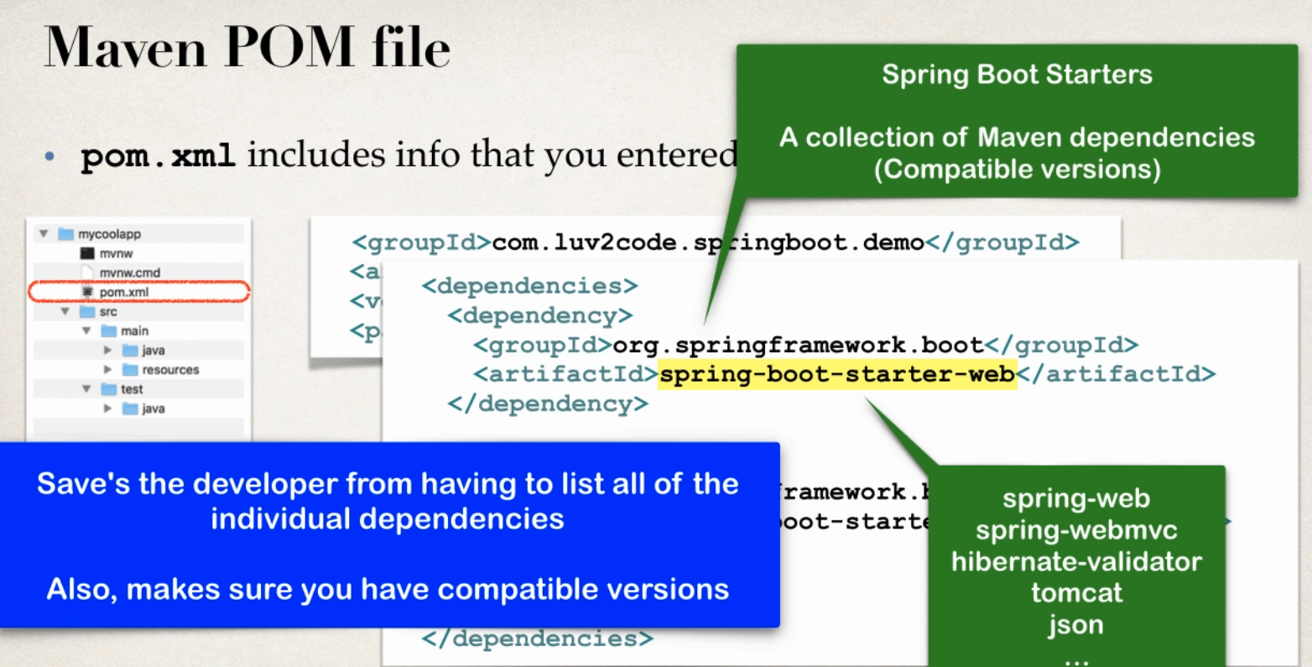

Spring Boot Starters - give colletion Maven dependencies for spring web dependcency all comptiable version handled by Spring boot

<dependency>

<groupId>org.springframework.boot</groupId>

<artifactId>spring-boot-starter-web</artifactId>

</dependency>

Spring Boot Starters

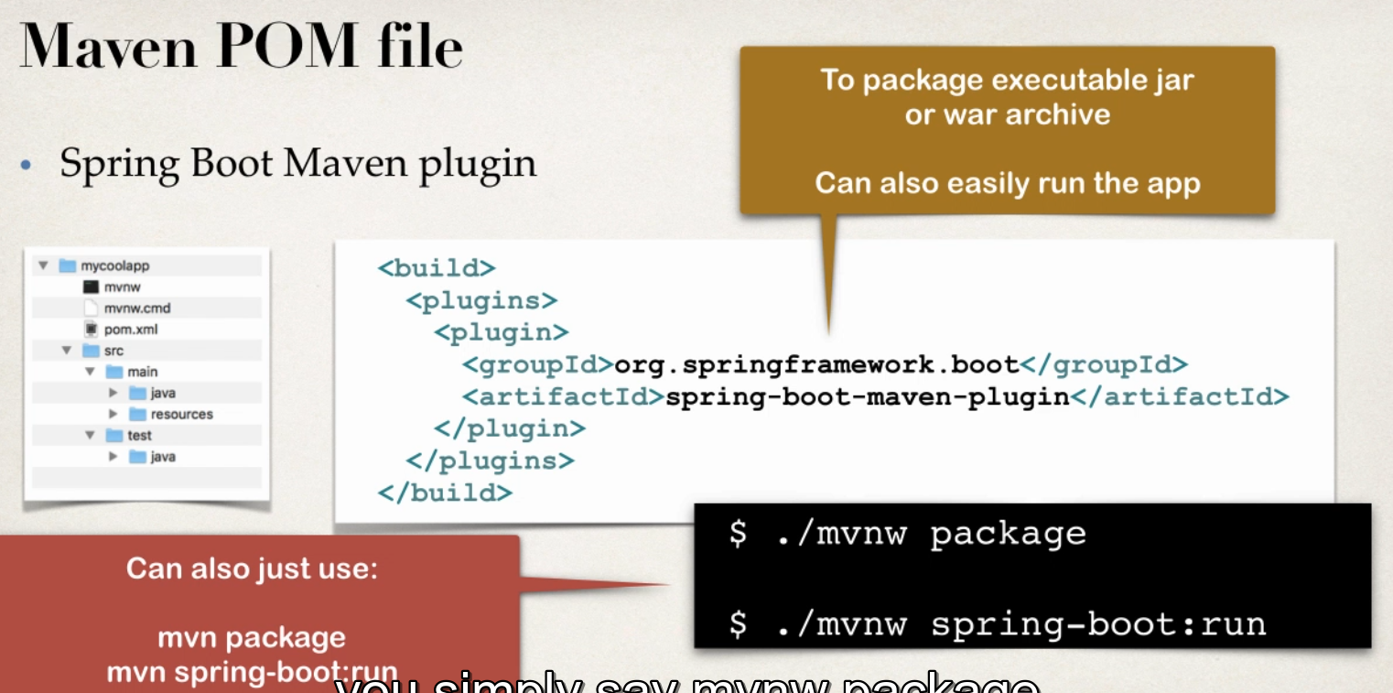

When Spring Boot Project is created

- main Spring Boot Application class created By Spring Initializr

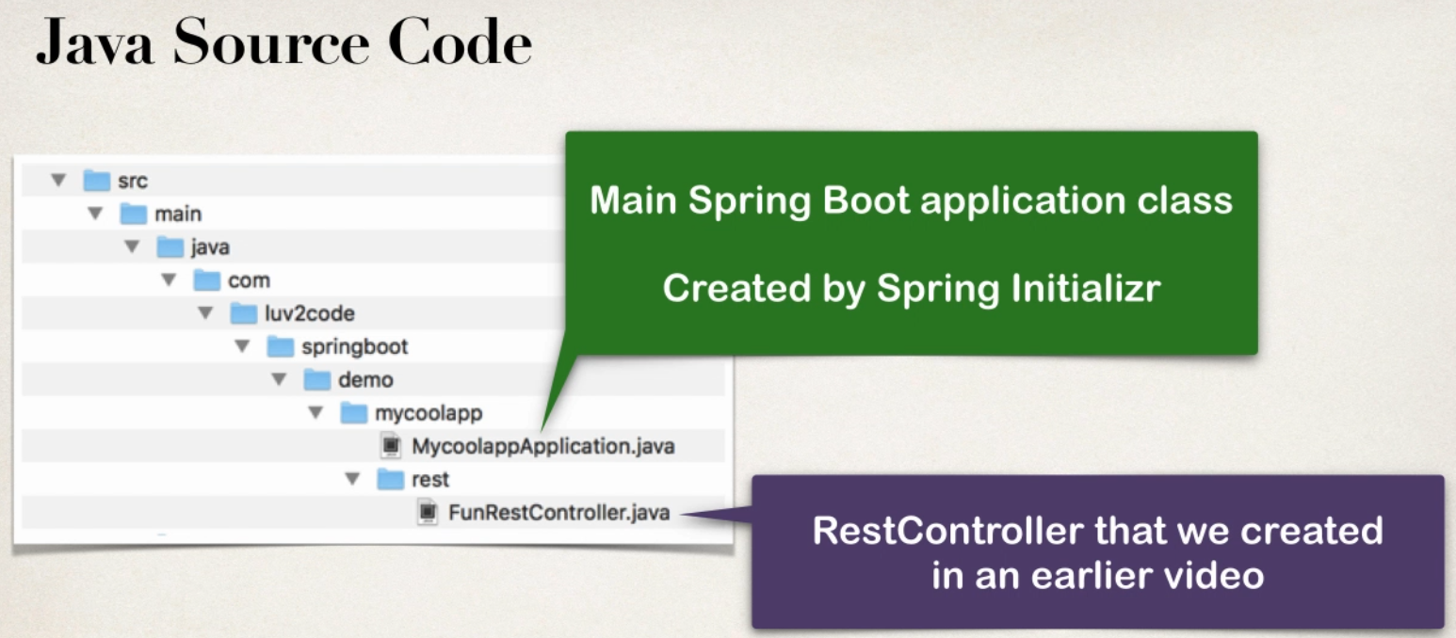

@SpringBootApplication

Composed of many components

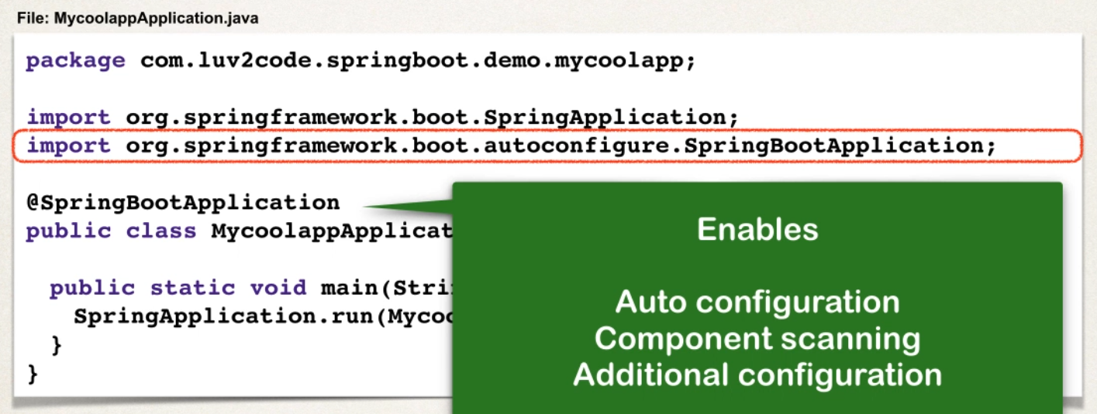

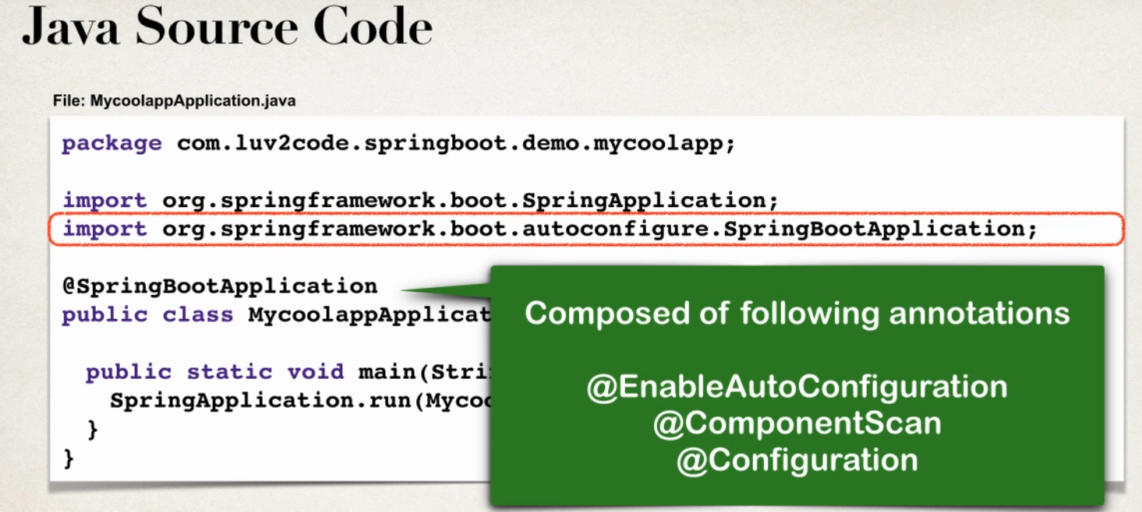

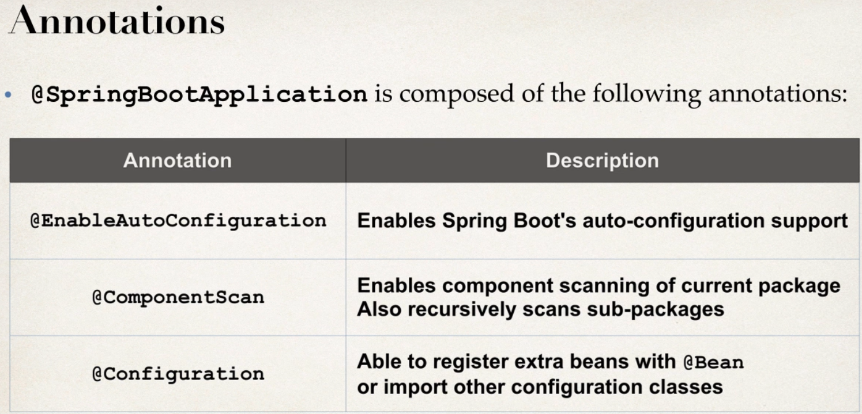

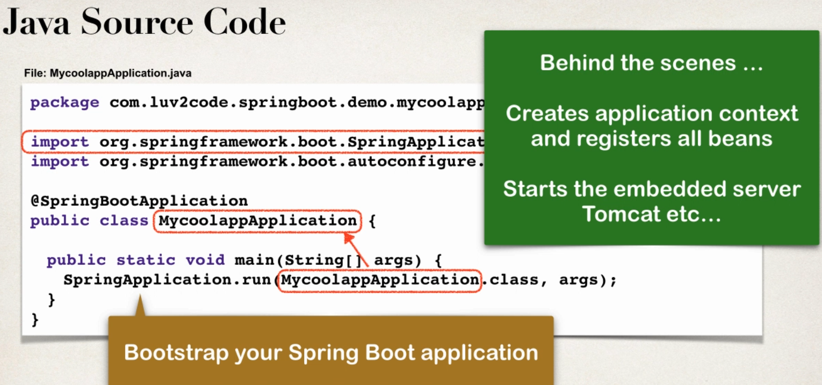

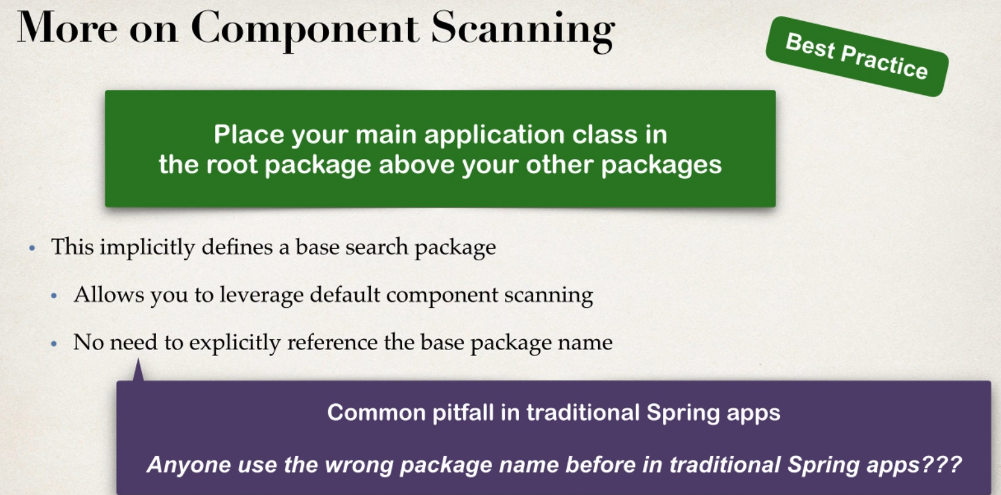

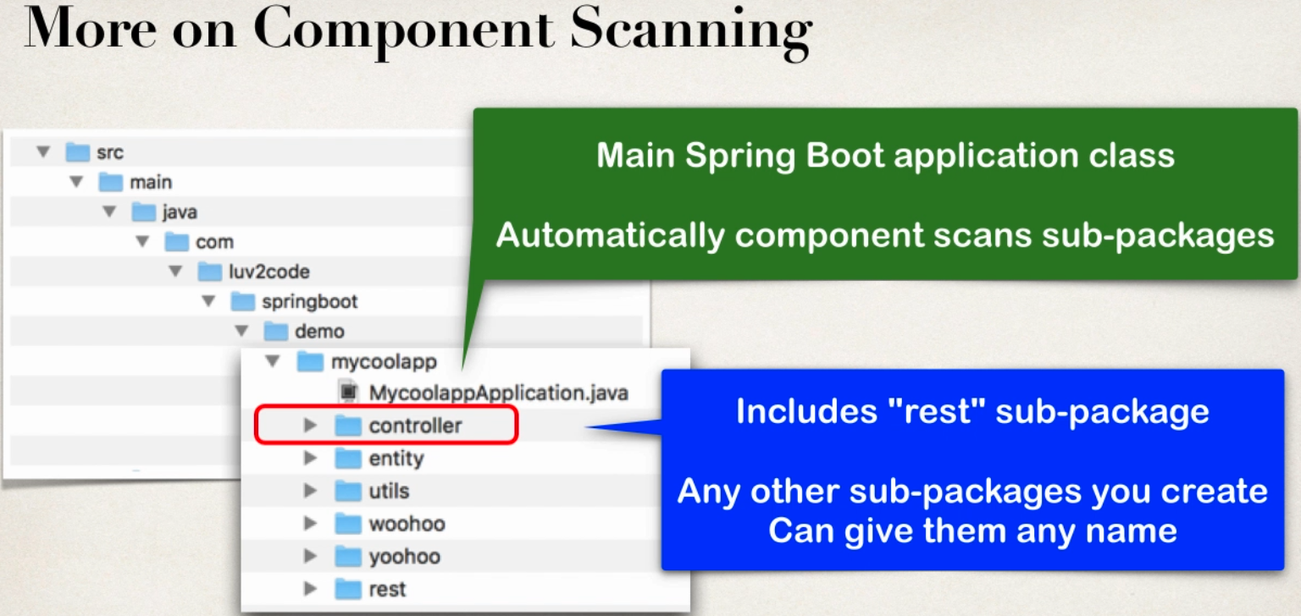

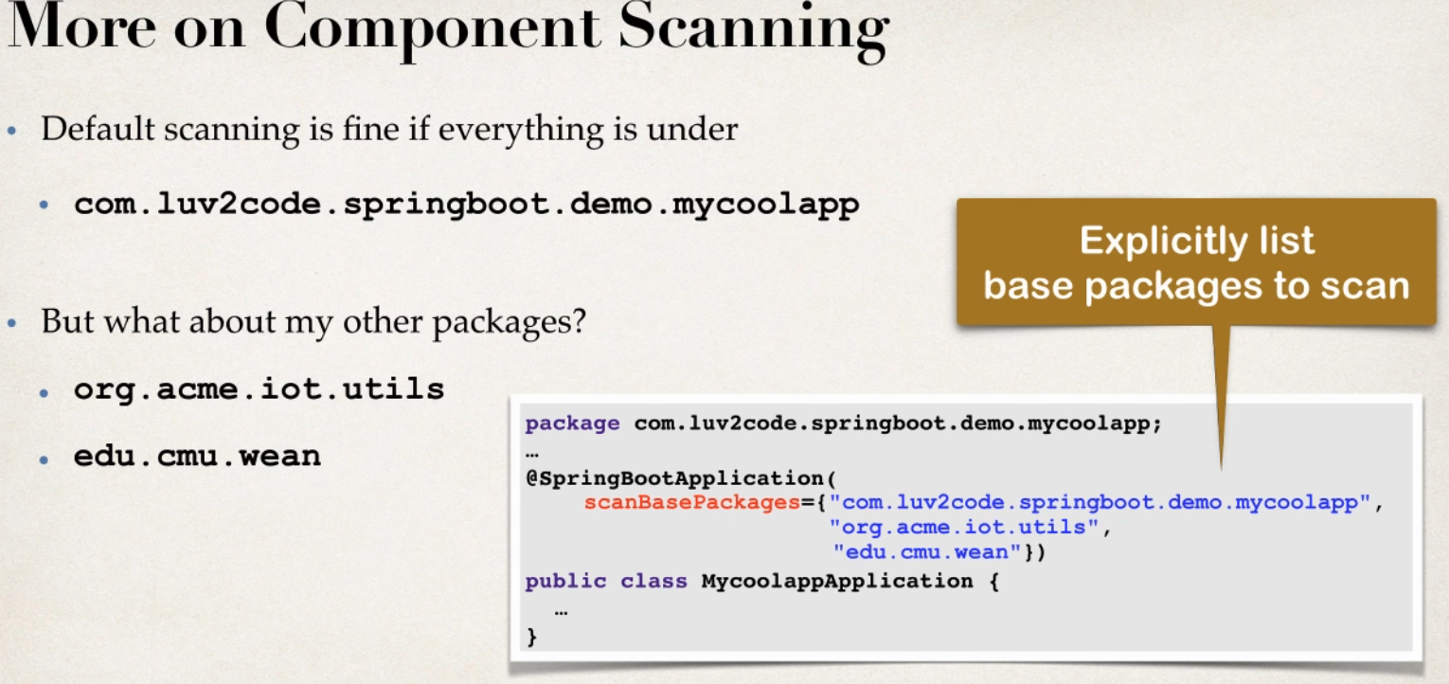

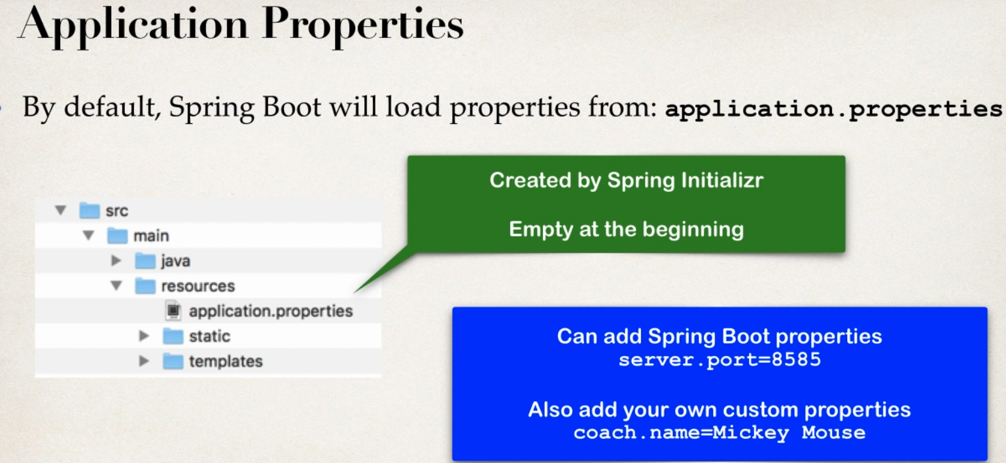

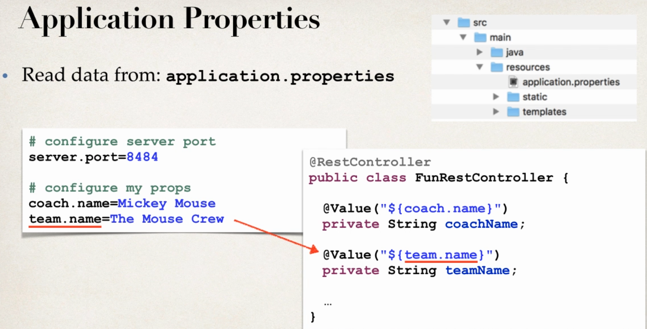

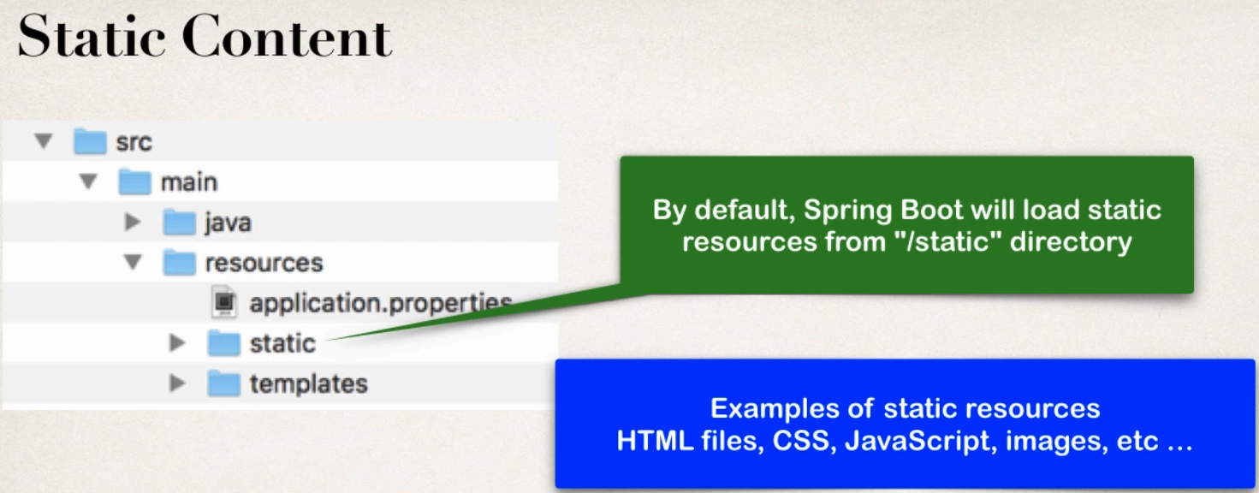

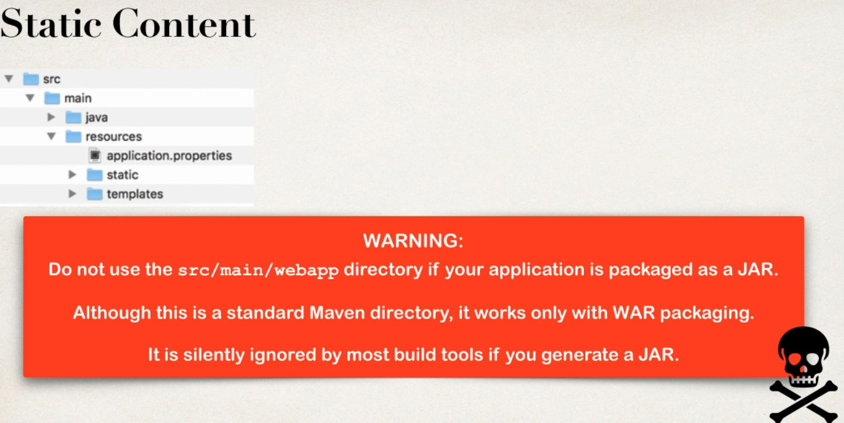

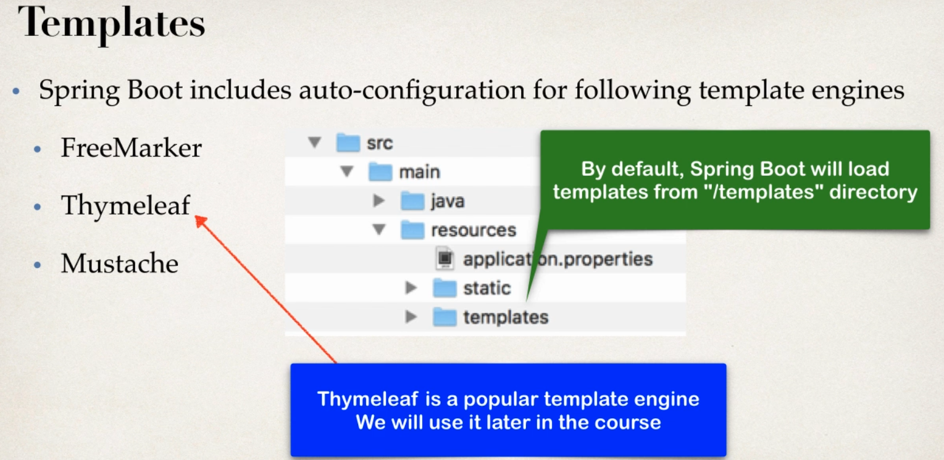

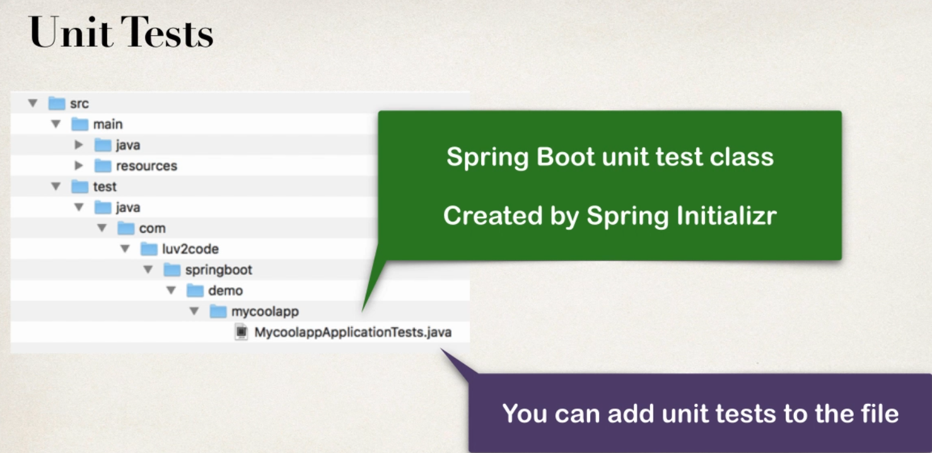

Spring Boot Starter

Problem

-Building a spring applciation is HARD

Which maven dependencies I need to use?

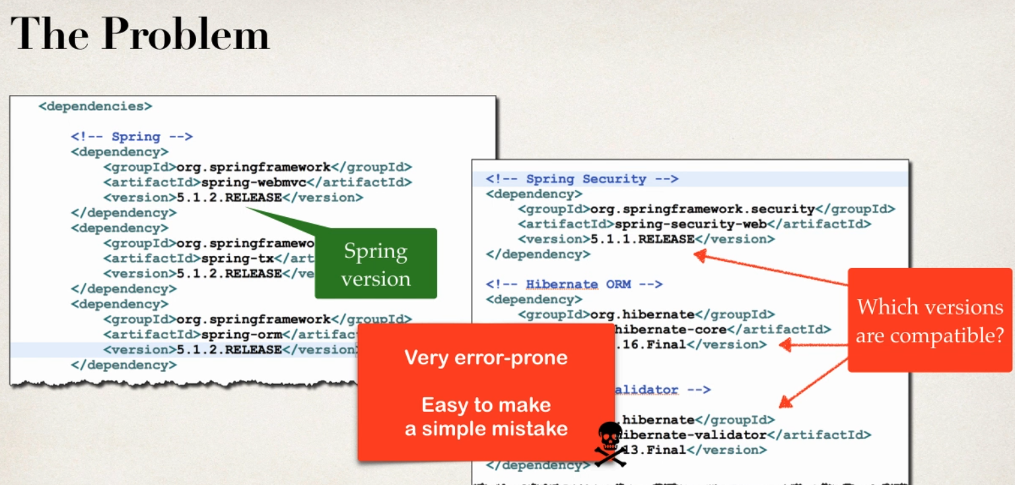

- it would be great if there was a simpler list of Maven depenceis

-collected group of dependencies one-stop-shop

- so no need to search for dependency

Solution is

SPRING BOOT STARTERS

- spring Boot Starters

- curated lsit of maven dependenceis

-collection of dependencies grouped together

-Test and verified by Spring Development Team

-much easier for developer to start

-reduce amount of Maven Configuration

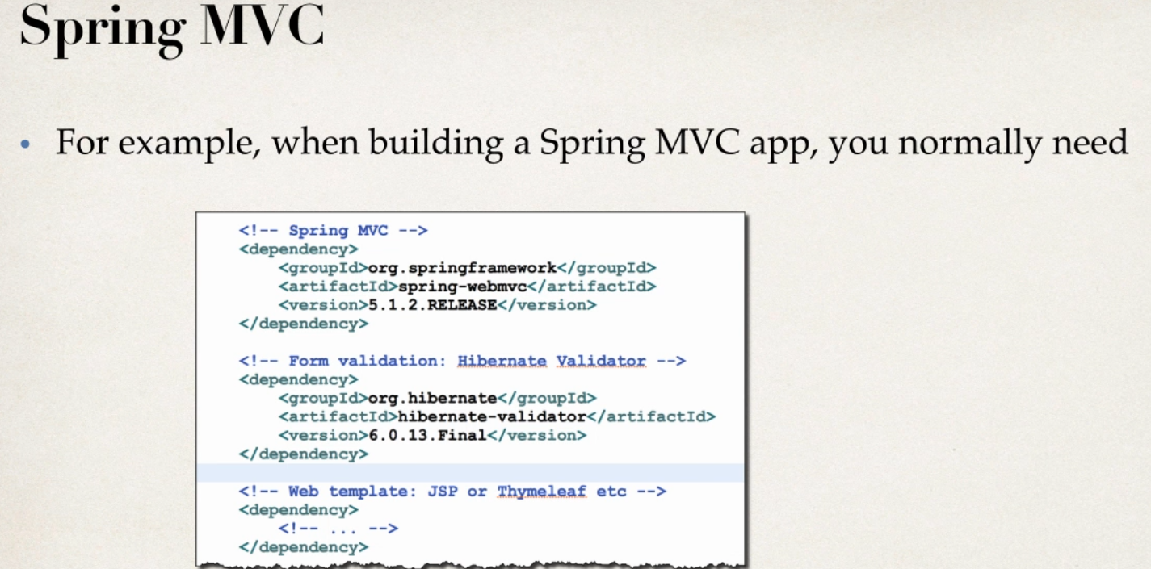

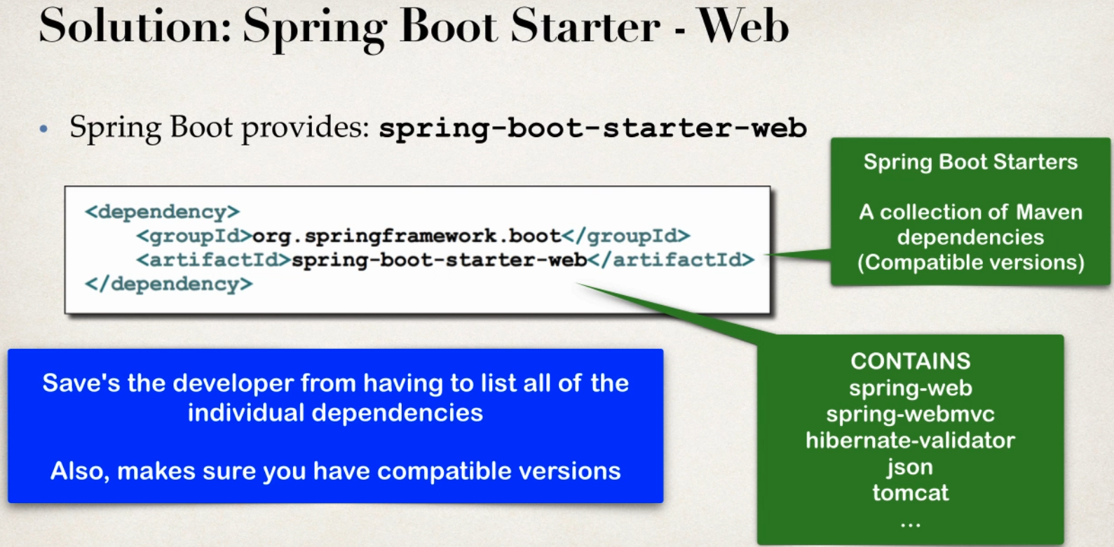

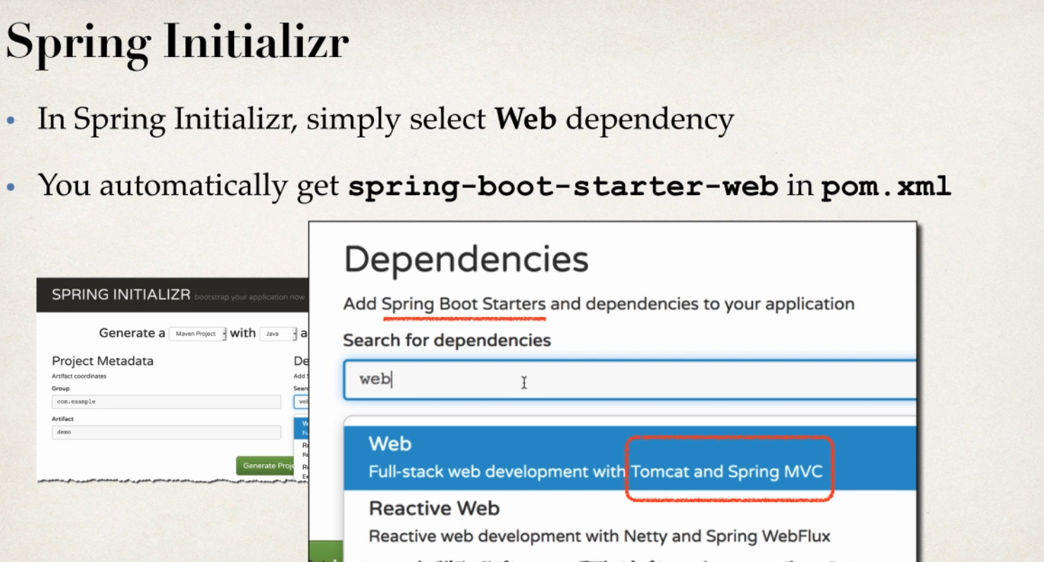

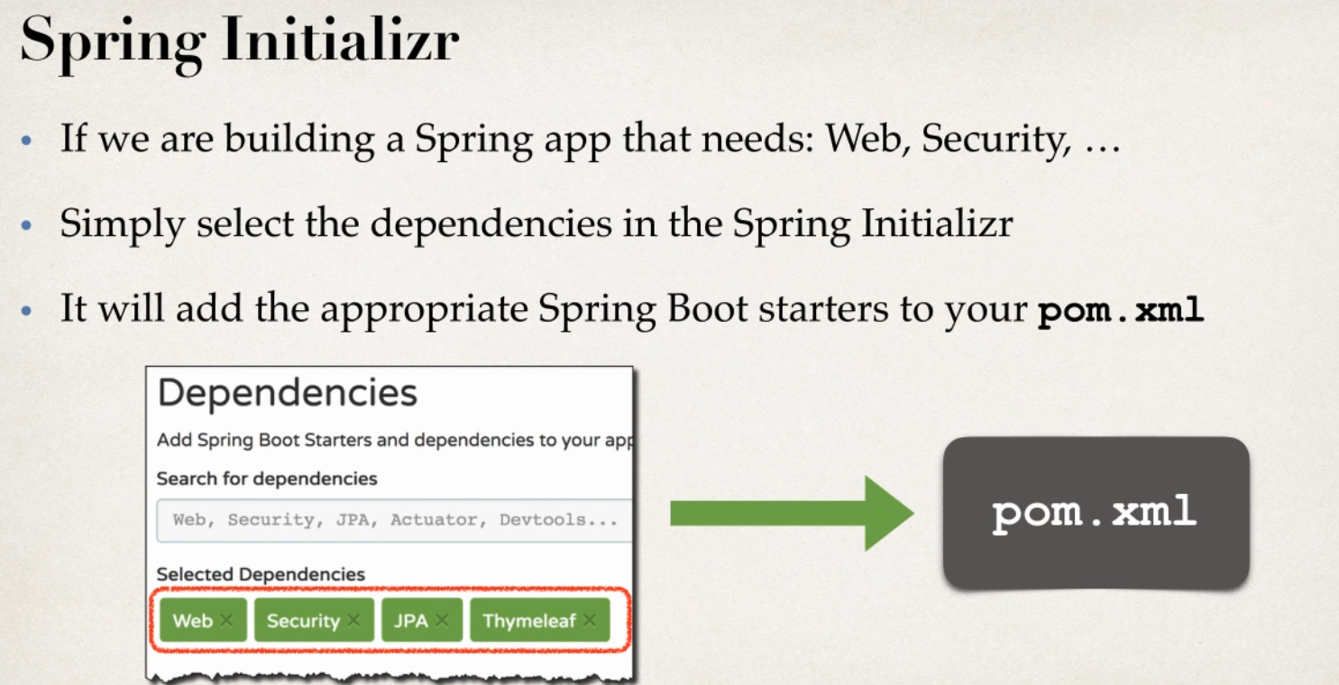

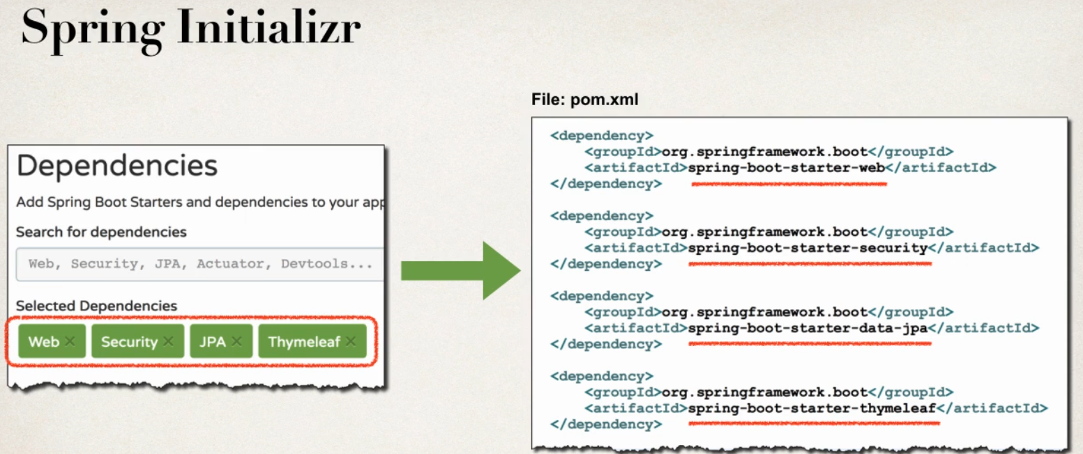

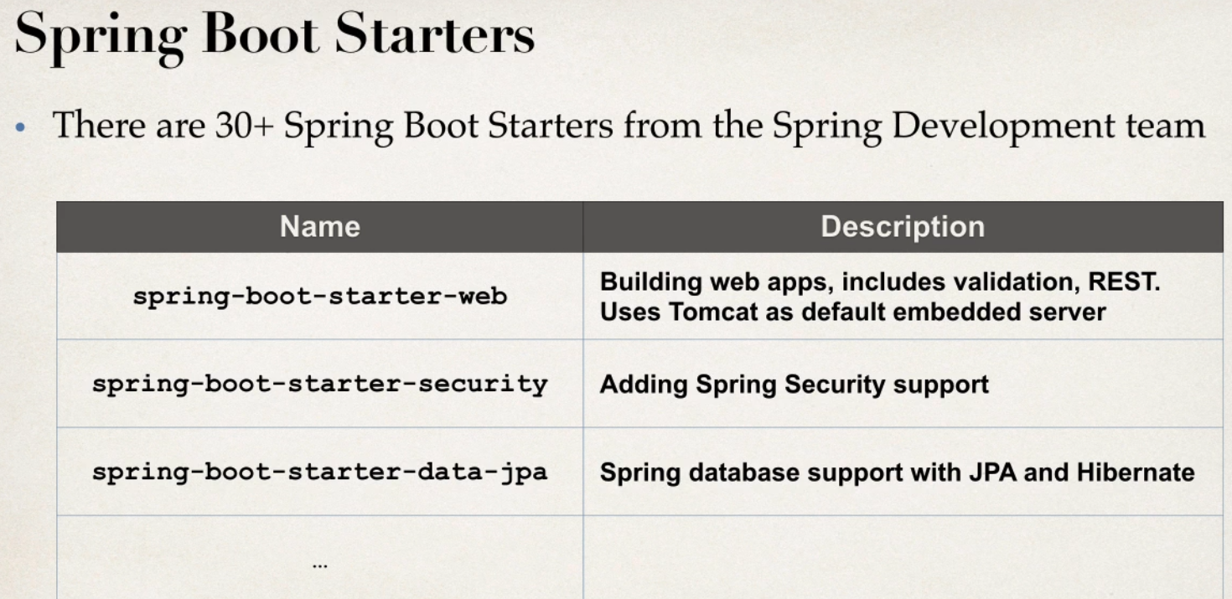

Just go thorugh the Spring Boot Listers in online to no dependencies

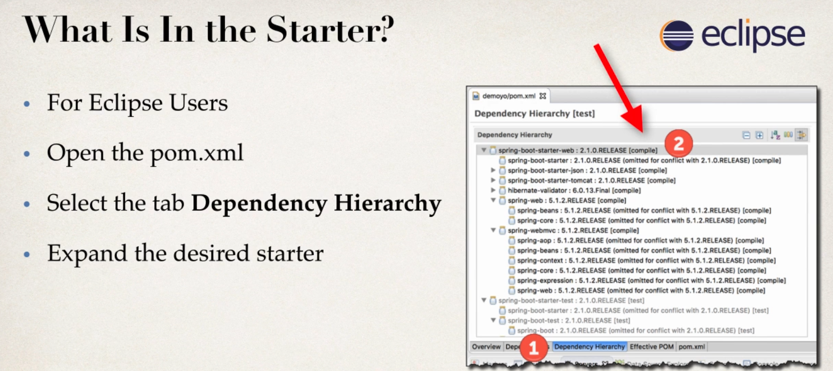

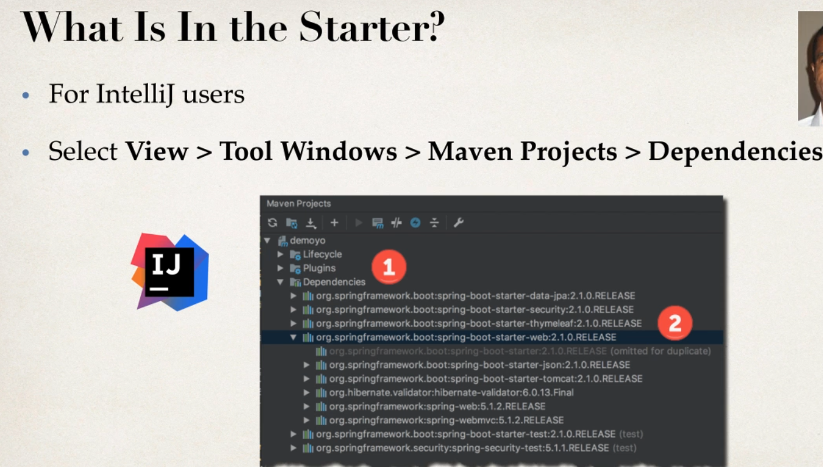

Spring Boot Starter Parent

